**Fridge Magnets game template**

Modulette ID:

Game #:

Game title: Fridge Magnets

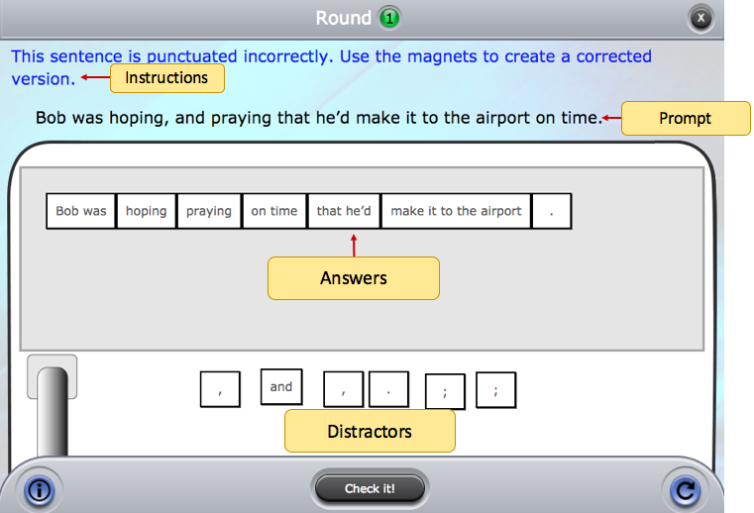

**Instructions:** (Use if instructions are the same for every round)

Round #

**Instructions:** (Use if the instructions are round specific)

**Prompt:** (Can be text or an image)

**Correct feedback:** (Message to display when answered correctly)

**General incorrect Feedback:** (Message to display when answered incorrectly)

**Correct answer values:** See example below. Phrases that form a single magnet go in brackets. Single word or symbol magnets should be separated by a space. An individually selectable punctuation also goes in brackets. Sometimes there will be more than one correct way to to build an answer. Overwrite the example with the answer for the round.

|  |
| --- |
| [Bob was] hoping and praying [that he’d] [make it to the airport] [on time] [.] |
| (alternate answer configuration) |
| (Alternate answer configuration, add rows for additional answers) |

**Distractors:** See example below. Phrases that form a single magnet go in brackets. Single word magnets should be separated by a space. Individually selectable punctuation goes in brackets. Overwrite the example with the distractors for the round.

|  |
| --- |
| [,] [,] and [.] [;] [;] [this would be a single magnet] |

**Specific Incorrect Feedback:** See example below. Enter values in the order that will trigger a specific incorrect feedback message.

|  |  |
| --- | --- |
| [Bob was] ; praying and hoping [on time] [make it to the airport] | [Specific Feedback] |
| (Incorrect answer configuration 2) | [Specific Feedback] |
| (Incorrect answer configuration 3) | [Specific Feedback] |